Day 1:

1) How long will it take the timer to roll over? 16 ms

2) How long does each timer count last? 1 us

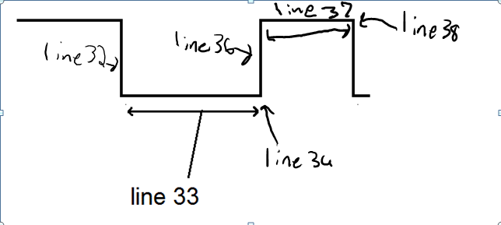

**IR data packets**

| **Pulse** | **Duration (ms)** | **Timer A counts** |
| --- | --- | --- |
| Start logic 0 half-pulse | 8.775 | 8775 |
| Start logic 1 half-pulse | 4.386 | 4386 |
| Data 1 logic 0 half-pulse | .637 | 637 |
| Data 1 logic 1 half-pulse | .465 | 465 |
| Data 0 logic 0 half-pulse | .624 | 624 |
| Data 0 logic 1 half-pulse | .465 | 465 |
| Stop logic 0 half-pulse | .637 | 637 |
| Stop logic 1 half-pulse | .467 | 467 |

| **Button** | **code (not including start and stop bits)** |
| --- | --- |
| 0 | 0x01d1027201d1 |
| 1 | 0x01d1027201d1 |
| 2 | 0x01d1027201d1 |
| 3 | 0x01d1027201d1 |
| Power | 0x01d1027201d1 |
| VOL + | 0x01cc025801f5 |
| VOL - | 0x01cc025301f5 |
| CH + | 0x01cc027a01d0 |
| CH - | 0x01cf027601ce |